Francisco tierraseca galdón
director OF fiiaPp
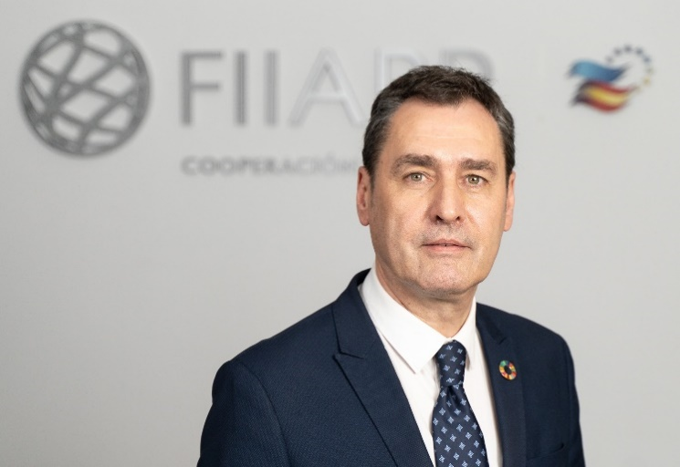
Born in Viviers (Ardèche-France), where his parents emigrated to in 1958, the family returned to Albacete after 20 years of residence in the neighbouring country.
He holds a degree in Political Science and Sociology, specialising in Political Science and Administration, and a Master's Degree in Peace, Security and Defence from the Instituto Universitario General Gutiérrez Mellado in Madrid. He is also a Specialist Technician in Delineation, specialising in Buildings and Public Works.
He is a career civil servant in the Corps of Secondary Education Teachers specialising in French and in the Corps of Technical Teachers of Vocational Training specialising in Construction Project Office. Currently employed as a senior civil servant in the General State Administration (AGE). He has developed his professional and political activity in the field of state public management and education at the levels of Higher Vocational Training, Baccalaureate and Secondary Education.
He has been Delegate of the Spanish Government in the autonomous community of Castilla-La Mancha from 2019 to 2023. Previously, he was Subdelegate of the Spanish Government in Albacete from 2018 to 2019. He has also served as a councillor on the Albacete City Council from 1995 to 1997.
He has taught for 28 years in schools in Puertollano (Ciudad Real), Alcantarilla (Region of Murcia), Cuenca and Albacete. Responsible for the ERASMUS+ European mobility programme for educational centres. In addition, he has directed exchanges and tutored workplace training for higher vocational training students in Portugal, Italy and France. He has been president of the Teaching Staff Board of Albacete (2015).
He is in possession of the Medal of Recognition for Service in the COVID 19 Pandemic awarded by UNIJEPOL (National Union of Local Police Chiefs and Managers) in collaboration with the FEMP (Spanish Federation of Municipalities and Provinces).
He has participated as co-author in the book "Latin America: two centuries of independence. Social, political and cultural fractures". Published by the Iberustyka Library of the Institute of Iberian and Ibero-American Studies of the University of Warsaw (2010).

In compliance with article 21.5 of Law 3/2015 regulating the exercise of senior positions in the General State Administration, the director's declaration of assets and patrimonial rights is available on the Transparency Portal.
In compliance with article 8 of Law 19/2013 on transparency, access to public information and good governance, the remuneration of senior management is available on the Transparency Portal and in the annual accounts published on the website.

